|  |  |
| --- | --- |
| NAME: | Atharva Gite |
| UID: | 2021300038 |
| BATCH: | A3 |
| EXPERIMENT NO: | 1 |

**GRAPHS:**

**OUTPUTS:**

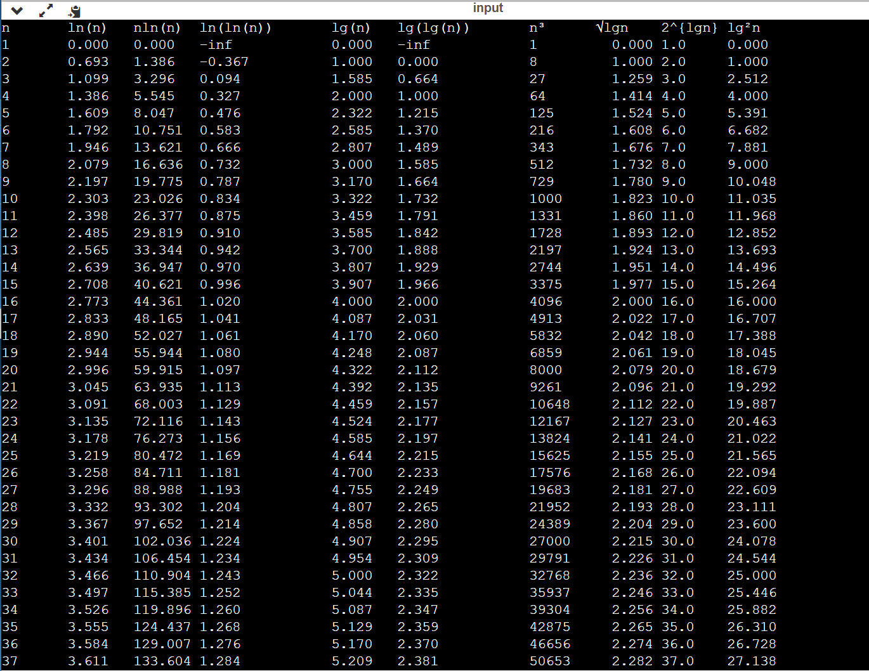

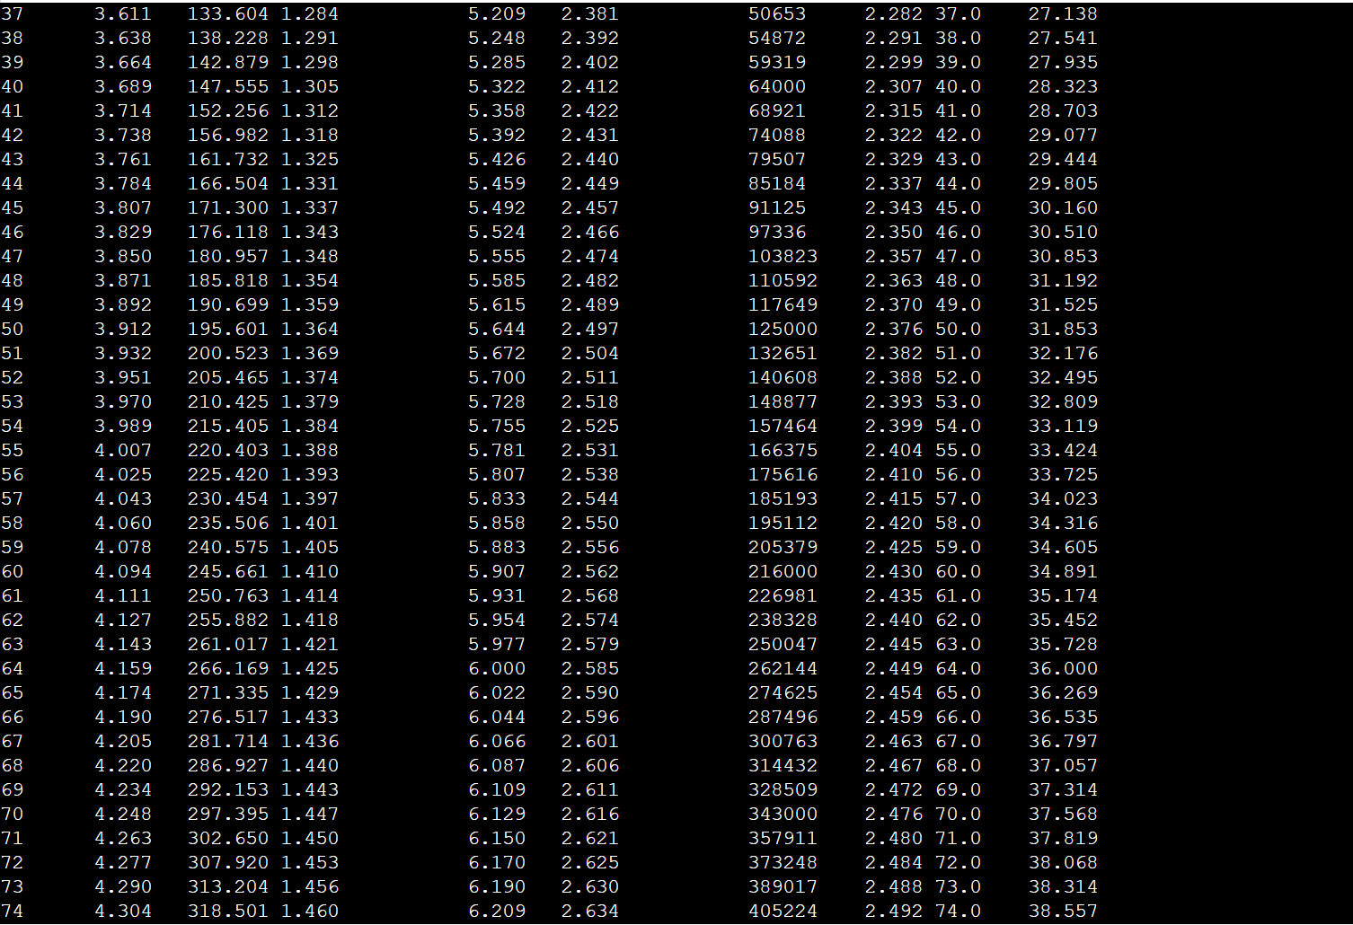

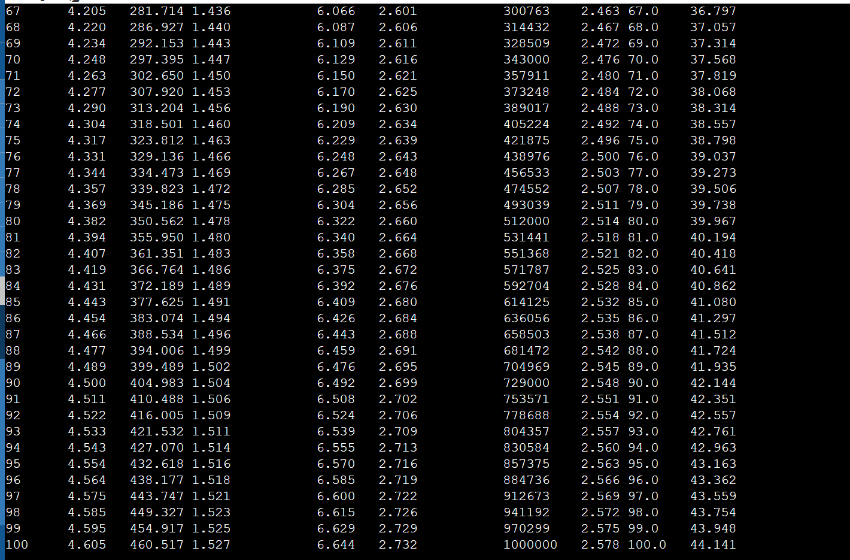

**CODE:**

#include <stdio.h>

#include <math.h>

double lnn(double n)

{

return log(n);

}

double logg2(double n)

{

return log2(n);

}

double power(double i,double a)

{

return pow(i,a);

}

int main()

{

int i;

printf("n\tln(n)\tnln(n)\tln(ln(n))\tlg(n)\tlg(lg(n))\tn³\t√lgn\t2^{lgn}\tlg²n\n");

for(i=1;i<101;i++)

{

printf("%d\t%0.3f\t%0.3f\t%0.3f\t\t%0.3f\t%0.3f\t  \t%d\t  %0.3f\t%0.1f\t%0.3f\n",i,lnn(i),i*lnn(i),lnn(lnn(i)),logg2(i),logg2(logg2(i)),i*i*i,power(logg2(i),0.5),power(2,logg2(i)),power(logg2(i),2));

}

}

#include <stdio.h>

long long int fact(int n)

{

if (n==0)

{

return 1;

}

else{

return n*fact(n-1);

}

}

int main()

{

int i;

for(i=0;i<21;i++)

{

printf("%lld \n",fact(i));

}

}